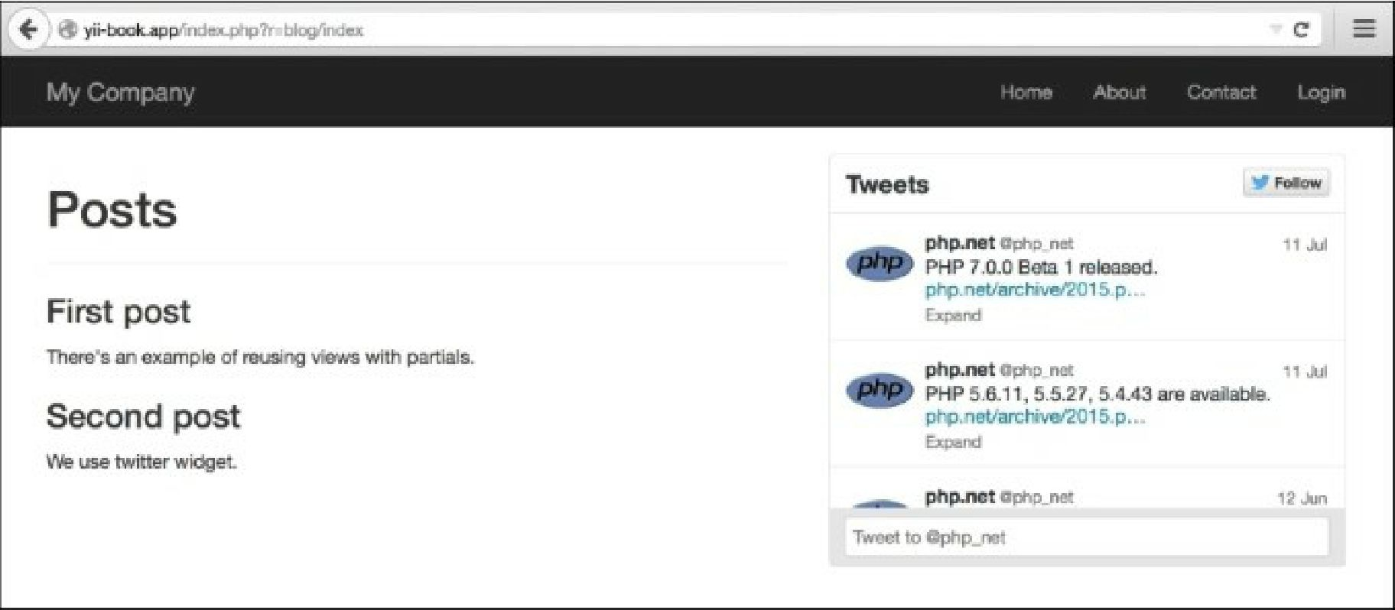

6. Try to run index.php?r=site/about:

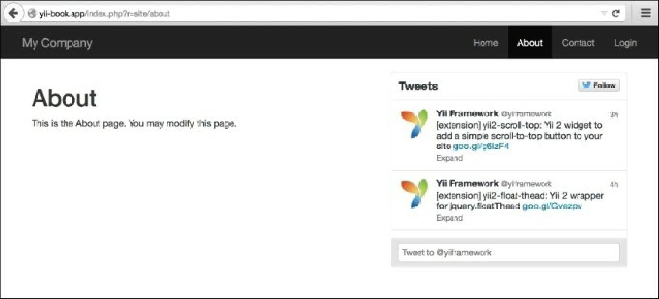

How it works...

In the current example, two views render @app/views/common/twitter. php with additional parameters for forming Twitter widgets inside themselves. Note that views can be rendered in controllers, widgets, or any other place, by calling the view rendering methods. For example, \yii\base\controller: : render does the same template processing as \yii\base\view: : render, except the former does not use layout.